|  |  |  |  |  |  |
| --- | --- | --- | --- | --- | --- |
| Date | December 14,2022 | | | Tester Name | Syed Shahabuddin |
| Environment | Penfax - Test | | | Login used |  |
| Operating System | Windows | Version: | Update: | | |
| Software Used | Edge | Version: | Update: | | |
| Select Software | Version: | Update: | | |
| Release version | 22.4.1 | | | | |
| Title | E23.11 | | | | |
| Test Type | Regression | | | | |
| Test Scenario | Change confirmation Letters | | | | |
|  |  | | | | |
| Expected Results | Verify the batch run successfully and letters generated and saved on member communications and visible on PLANet member  Check several members - both PEPP (active and deferred) & VPB members (active)  *Note: Business currently only mails letters for VPB banking, tax, scheduled payment and min age letters. No PEPP letters currently are mailed.*  Data records to update/check on Penfax:   * Address * Contact info (phone/email) * Beneficiary change * Banking info (Payment Instruction change) * Tax Instruction change * VPB Scheduled Payment change (fixed & ITA minimum) * Minimum age (change from member to spouse for mbr 72 or over) * (Note: stop a scheduled payment doesn’t produce letter/isn’t supposed to.) | | | | |
| Pass/Fail | Pass | | | JIRA# | N/A |

|  |  |  |  |
| --- | --- | --- | --- |
| **Stakeholder** | **Last name** | **Test case scenario** | **Result** |
| 318074 | Zaba | PEPP Member Address change | Check, in communications, not registered for PlaNet, letter shows new address |
| 284777 | Zabos | Contact info (phone/email) | Check, in com tab, not reg. for PlaNEt, letter shows what it was changed to |
| 253529 | Zalys | Deposit Allocation Change | *interfund transfer letter generates (not change confirmation) |
| 283089 | Zafar | PEPP Member Beneficiary Change | Check, on PlaNet and communications, letter shows new ben designation |
|  |  |  |  |
| 299924 | Zaba | VPB Member Beneficiary change | Check, in comm and PlaNet, letter shows new ben info |
| 248489 | Zacharias | VPB Member Address change | Check, in comm, no planet reg., letter shows addy change |
| 252537 | Zaron | VPB Member Banking info (Payment Instruction change) | Check, good letter says banking info |
| 300387 | Zazula | VPB Member Tax Instruction change | Check, good letter say TD1 info change |
| 307454 | Zerr | VPB Scheduled Payment change (fixed) *added fee | Check, good letter includes feee and amount of vpb pmt update |
| 198101 | Zimmerman | VPB Scheduled Payment change (ITA minimum)  *specified and annual | Check, letter good.  Letter shows pmts start nov 4 (matches with the 17 business day’s before end of month payroll which is in Plan Rules and updated for testing). ITA minimum. No fee included on letter. |
| 249567 | Zuk | Minimum age (change from member to spouse for mbr age 72 or over) | Check, letter good, indicates min age change |

Zuk

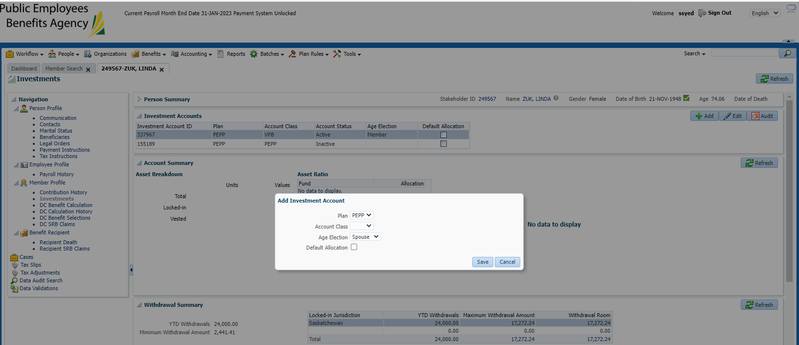

Zimmerman (specified, ita min, annual)

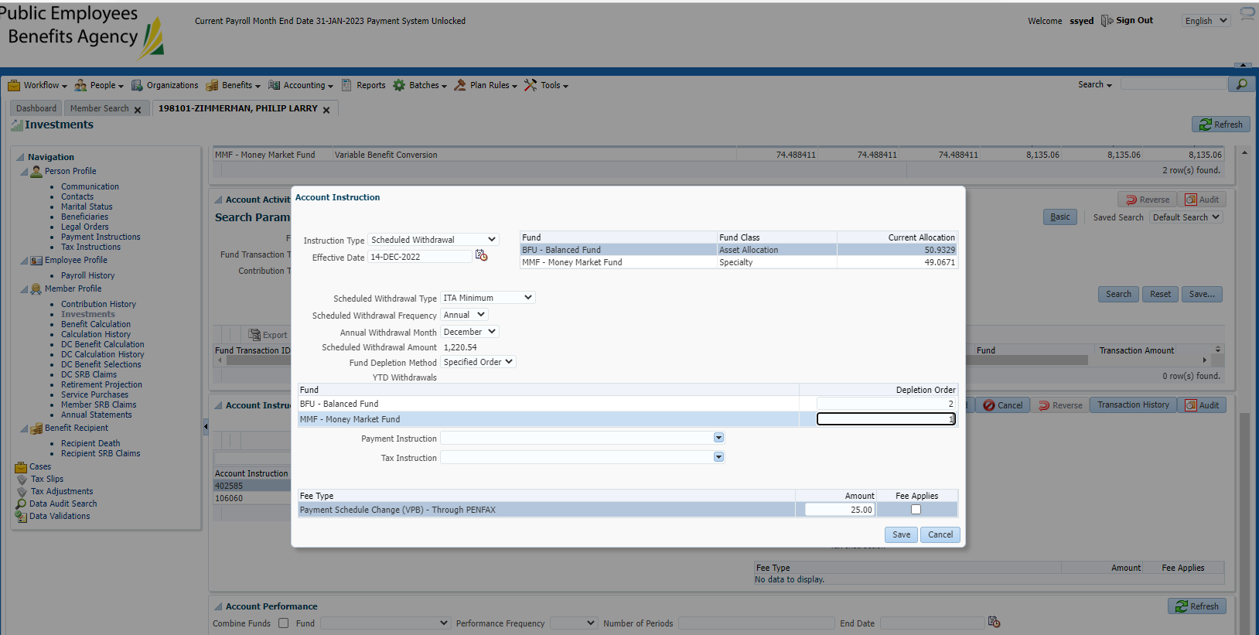

Zerr

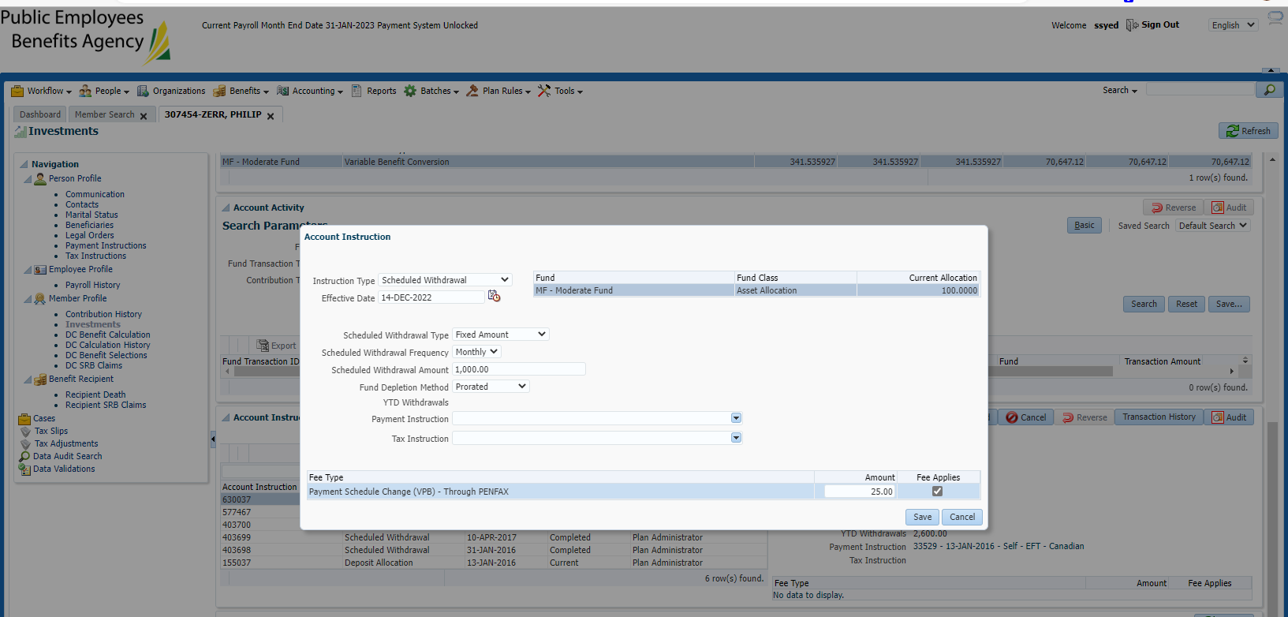

Zazula

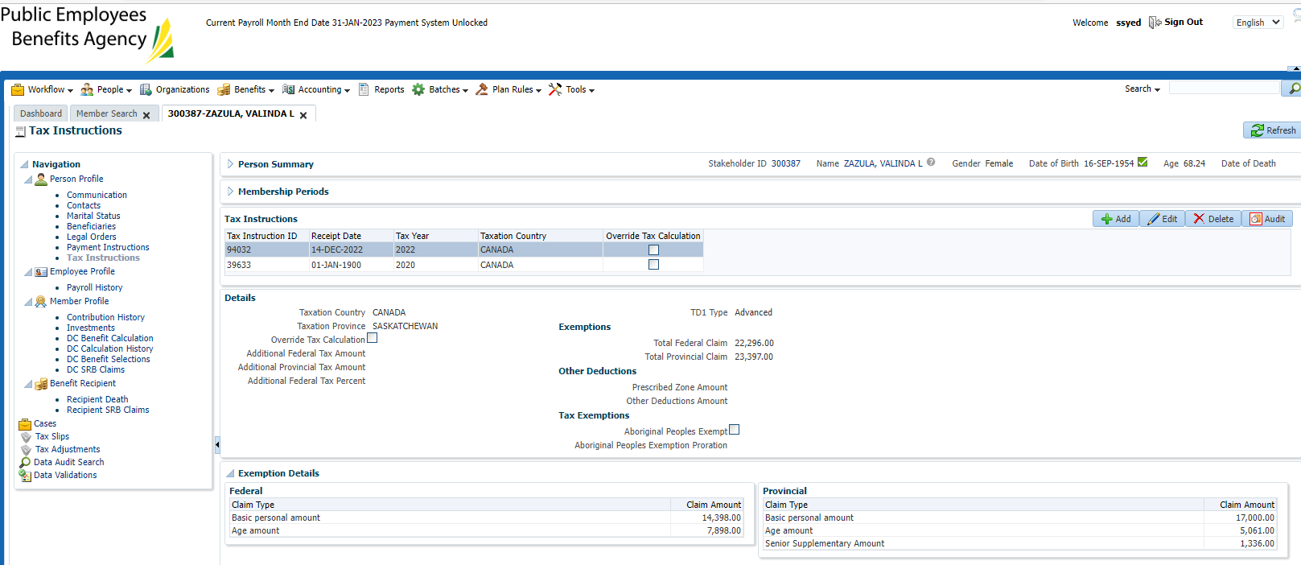

zaron

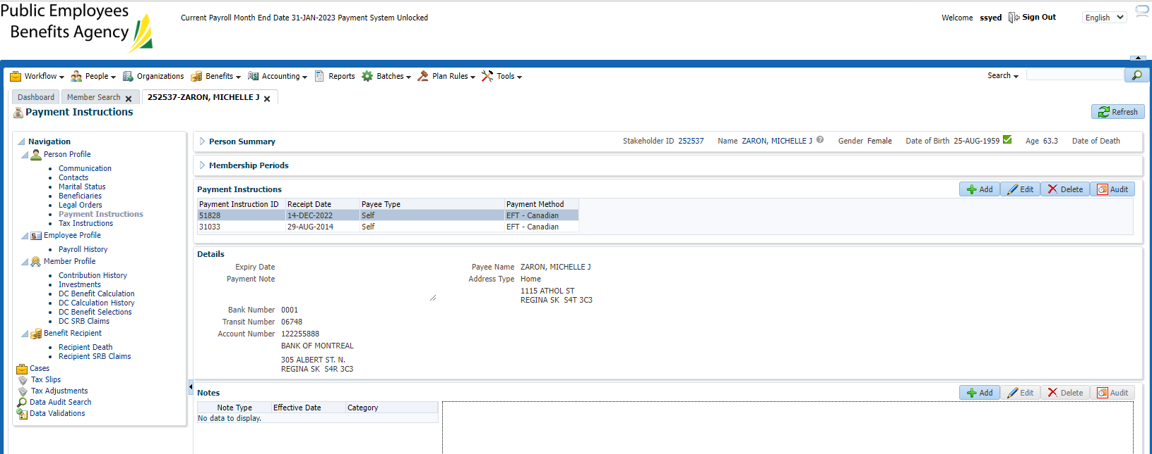

Zacharias

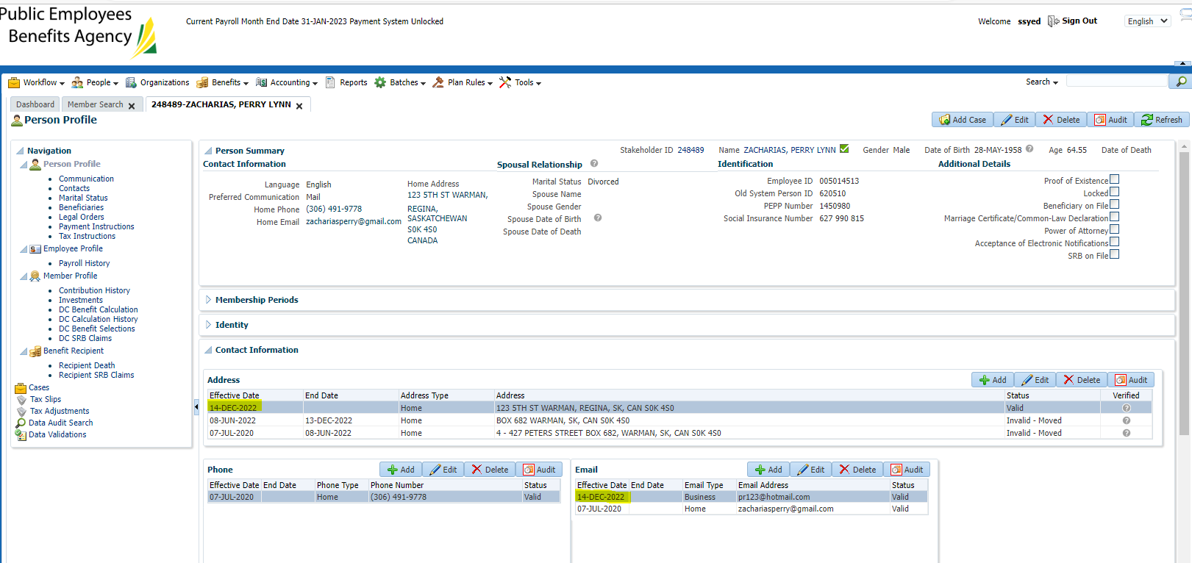

Zaba:

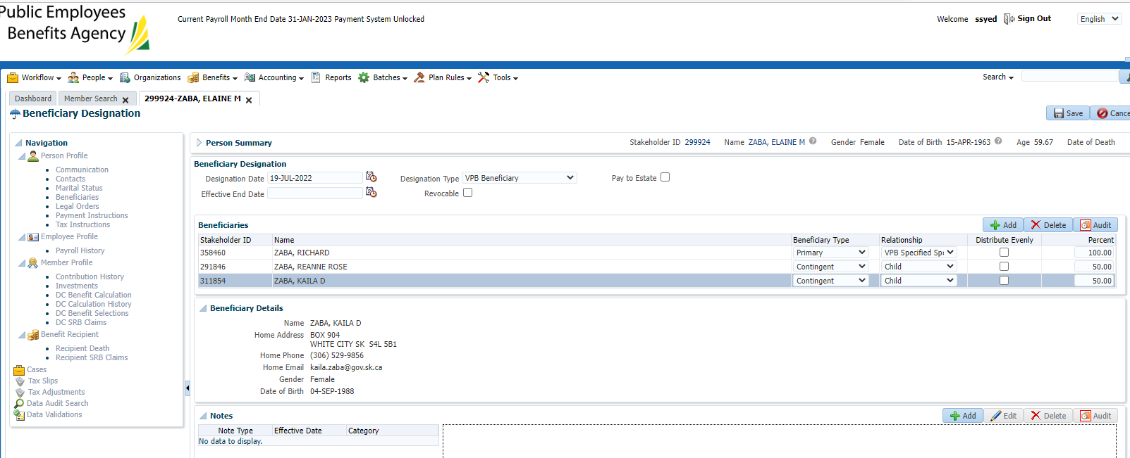

Zalys:

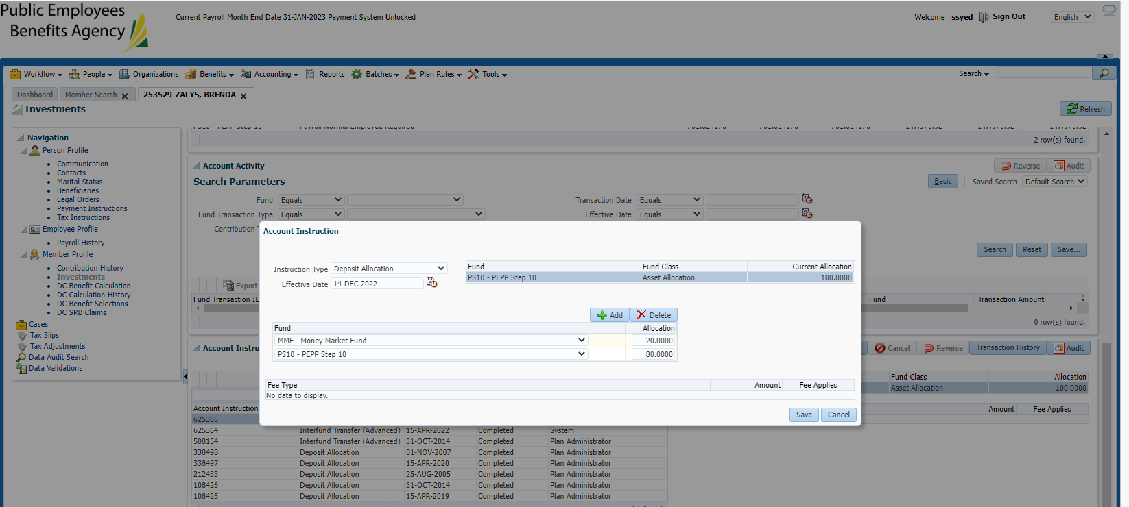

Zabos:

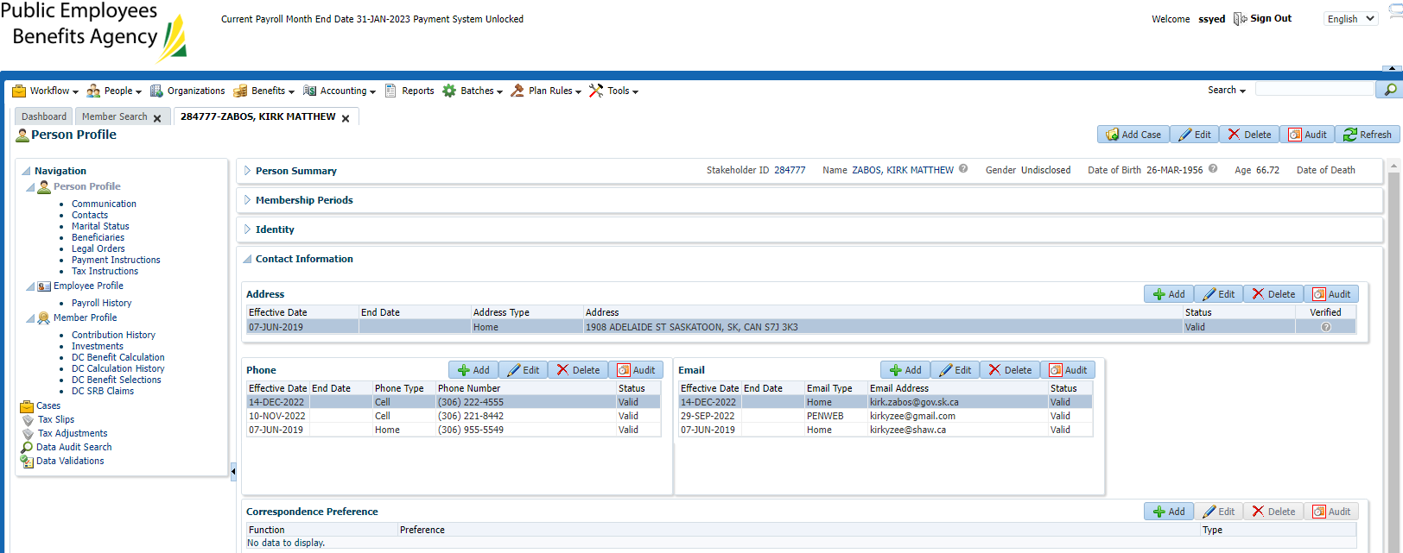

Zafar:

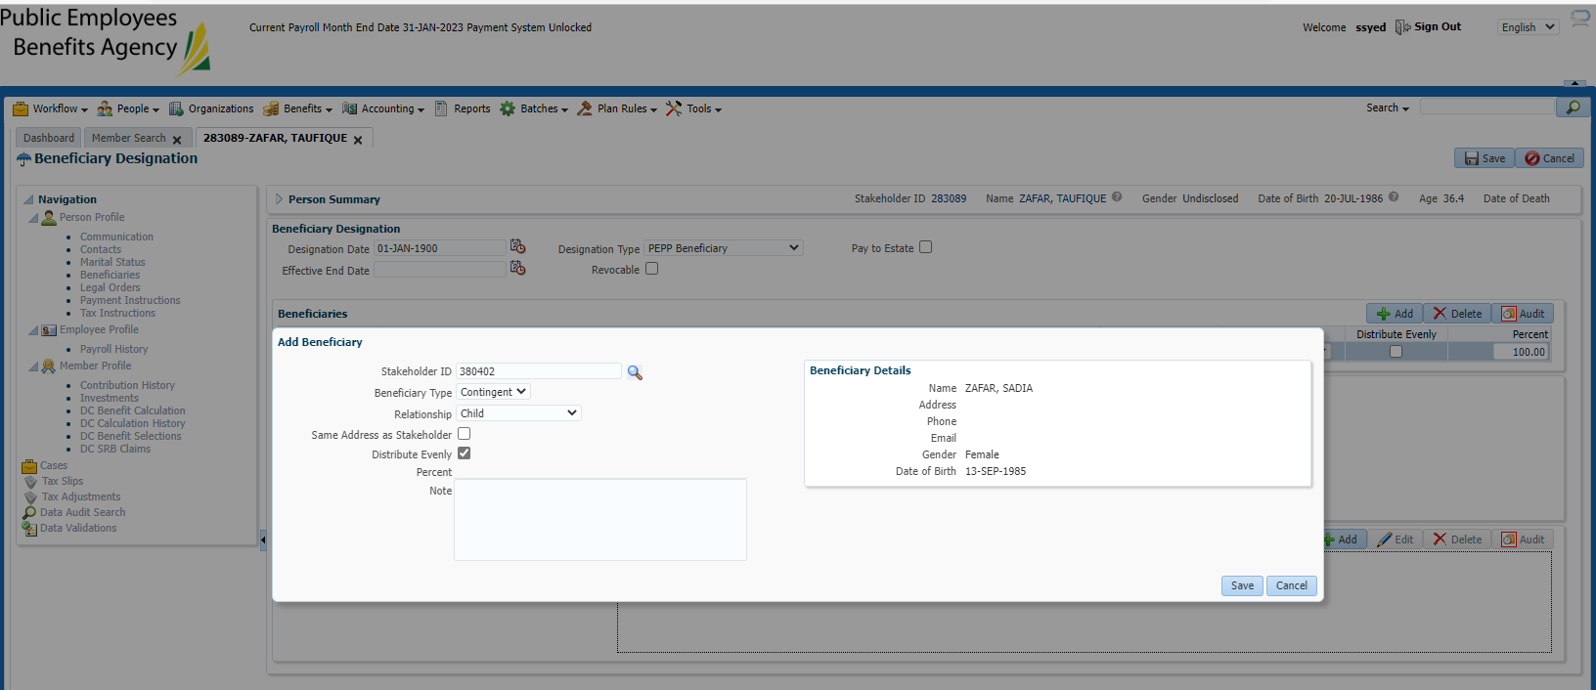

Batch succeeded – next day:

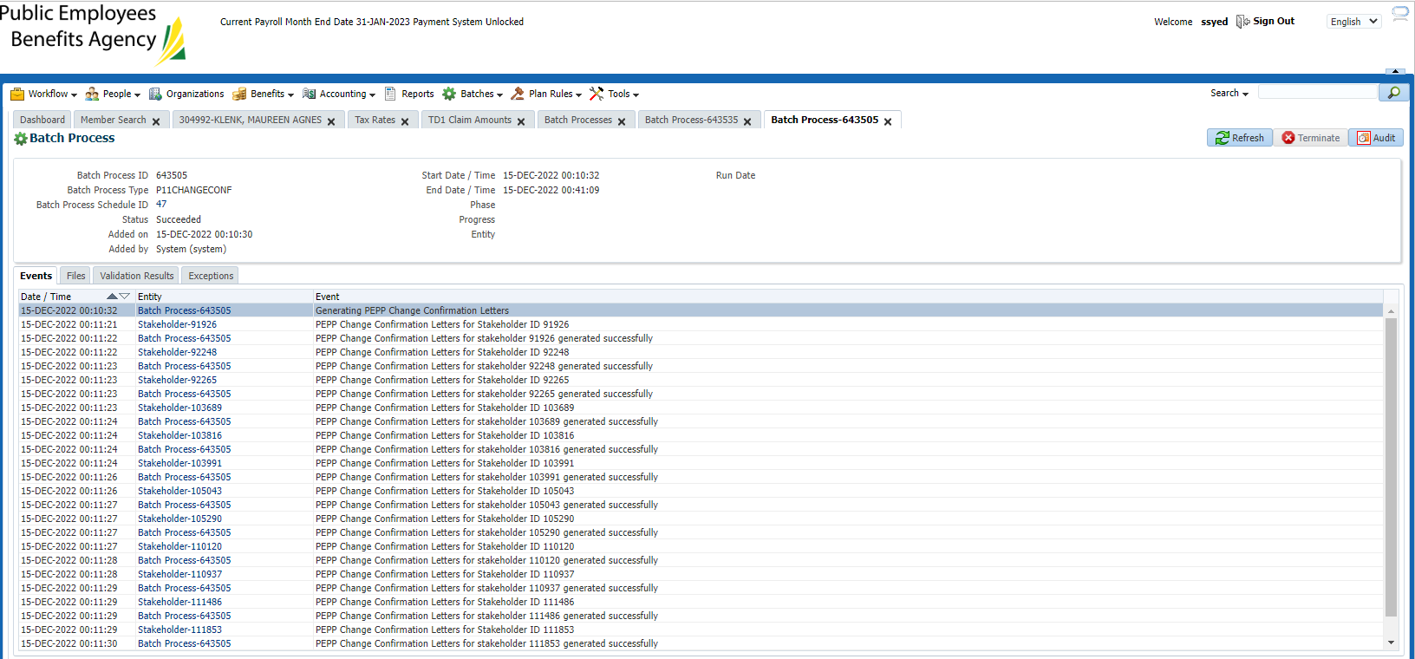

Checking list to ensure all changes appear on letter (may be others due to other processors):

